ReCOA COB Cross Product Spread

Overview

Current processing
None.

New requirement
- In COB for cross product spreads project, CBOEDirect will implement a “best effort”
strategy, where CBOEDirect will monitor NBBO/BOTRs in all cross product spread legs, including the equity leg, for triggering the reCOA process of the booked cross product spread orders.

Implementation
- A new service reCOAService will be created under businessServices directory, and move all ReCOA*.java code from brokerService to this new service directory.
- reCOAService will receive option BOTR and underlying NBBO data through BestOfTheRestConsumer event channel:
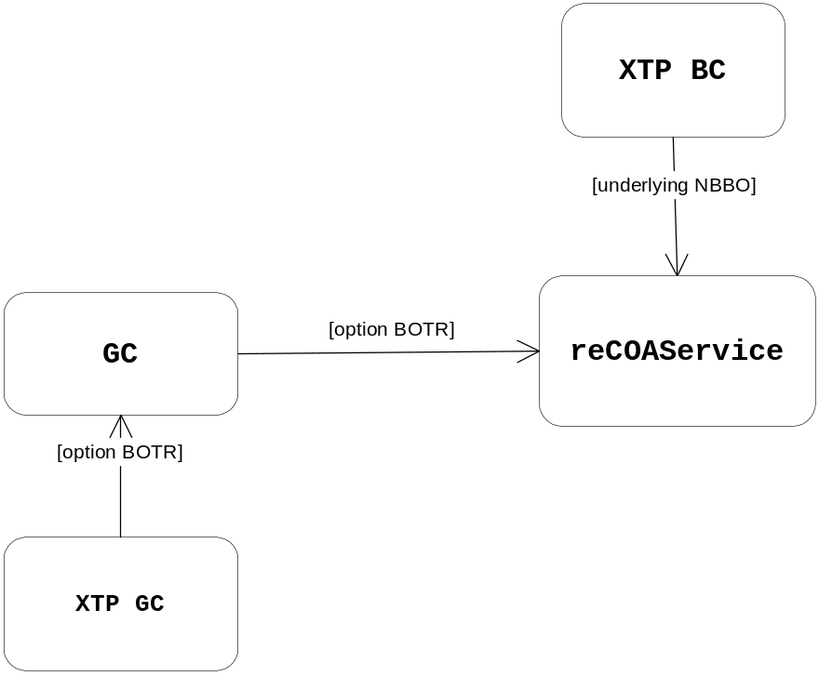
- Upon receiving option BOTR/underlying NBBO update, reCOAService will apply reCOA throttling logic. Once the throttling is passed, the service will evaluate the cross product orders’ COA’ability:
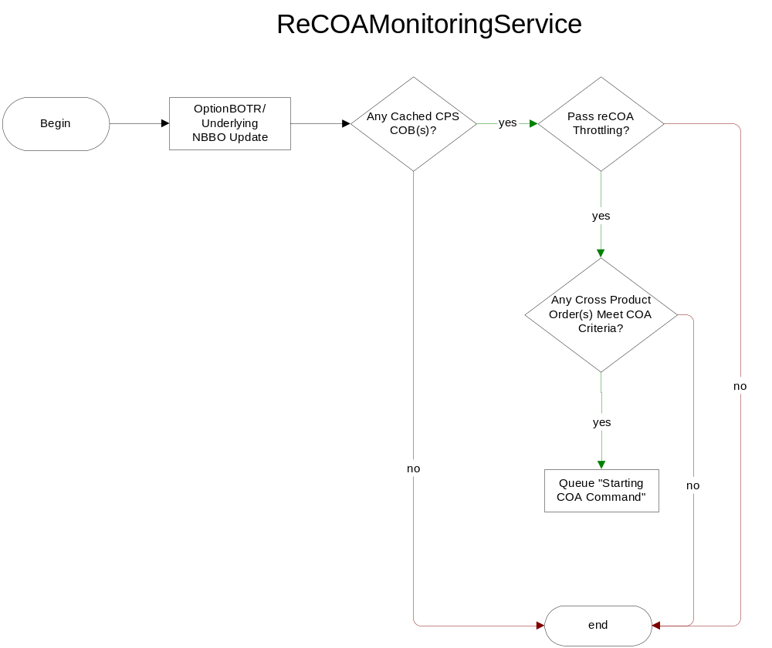
- Under /vobs/dte/server/Java/impls/com/cboe/businessServices directory, create:
ReCOAMonitoringServiceHome.java
{
public static final String HOME_NAME = "ReCOAMonitoringServiceHome";
public ReCOAMonitoringService create(String name);
public ReCOAMonitoringService find();
}
ReCOAMonitoringService.java
- Under businessServices/reCOAService directory, create:
ReCOAMonitoringServiceHomeImpl.java
- implement “protected void connectToConsumers()”, where it will connect to BestOfTheRestConsumer
ReCOAMonitoringServiceImpl.java
- implement BestOfTheRestConsumer
- implement “public void acceptNBBODataBuffer()” and add reCOA for CPS order logic here
- implement “public void acceptBestOfTheRest()” and add reCOA for CPS order logic here
- empty implementation for the rest of the BestOfTheRestConsumer methods

Scripts
- None

Database
- None

SetContext
- None

XML/DTD
- None

Trading Property
- None

Homes/Services
- None

ImplPlan
- None

PerformanceTestingProcedure
- None

TestingProcedure
- None

OperatorProcedure
- None

Fallback/Failover
- None

